UNITED STATES
SECURITIES AND EXCHANGE COMMISSION
WASHINGTON, D.C. 20549

FORM 8-K

CURRENT REPORT

Pursuant to Section 13 or 15(d) of the Securities Exchange Act of 1934

Date of Report (Date of earliest event reported): September 29, 2026

uniQure N.V.
(Exact Name of Registrant as Specified in Charter)

The Netherlands |  | 001-36294 |  | N/A
(State or Other  Jurisdiction of Incorporation) |  | (Commission  File Number) |  | (IRS Employer  Identification No.)

Paasheuvelweg 25a,  1105 BP Amsterdam, The Netherlands |  | N/A
(Address of Principal Executive Offices) |  | (Zip Code)

Registrant’s telephone number, including area code: +31-20-240-6000

(Former Name or Former Address, if Changed Since Last Report)

Check the appropriate box below if the Form 8-K filing is intended to simultaneously satisfy the filing obligation of the registrant under any of the following provisions (see General Instruction A.2. below):

☐ | Written communications pursuant to Rule 425 under the Securities Act (17 CFR 230.425)

☐ | Soliciting material pursuant to Rule 14a-12 under the Exchange Act (17 CFR 240.14a-12)

☐ | Pre-commencement communications pursuant to Rule 14d-2(b) under the Exchange Act (17 CFR 240.14d-2(b))

☐ | Pre-commencement communications pursuant to Rule 13e-4(c) under the Exchange Act (17 CFR 240.13e-4(c))

Securities registered pursuant to Section 12(b) of the Act:

Title of each class: |  | Trading Symbol(s) |  | Name of each exchange on which registered:
Ordinary Shares, par value €0.05 per share |  | QURE |  | The Nasdaq Stock Market LLC
 |  |  |  | The Nasdaq Global Select Market

Indicate by check mark whether the registrant is an emerging growth company as defined in Rule 405 of the Securities Act of 1933 (§230.405 of this chapter) or Rule 12b-2 of the Securities Exchange Act of 1934 (§240.12b-2 of this chapter).

Emerging growth company ☐

If an emerging growth company, indicate by check mark if the registrant has elected not to use the extended transition period for complying with any new or revised financial accounting standards provided pursuant to Section 13(a) of the Exchange Act. ☐

Item 7.01 Regulation FD Disclosure.

On September 29, 2026, uniQure N.V. (the “Company”) presented an update of its ongoing clinical trials of AMT-130 (the “Presentation”) and issued a press release which summarizes the Presentation (the “Release”).

Copies of the Presentation and Release are furnished herewith as Exhibit 99.1 and Exhibit 99.2, respectively, and are incorporated into this Item 7.01 by reference.

The information in this Item 7.01 of this Current Report on Form 8-K, the Presentation and the Release, shall not be deemed “filed” for purposes of Section 18 of the Securities Exchange Act of 1934, as amended, or otherwise subject to the liabilities of that section or Sections 11 and 12(a)(2) of the Securities Act of 1933, as amended. The information contained in this Item 7.01, and in the Presentation and the Release, shall not be incorporated by reference into any filing with the Securities and Exchange Commission made by the Company, whether made before or after the date hereof, regardless of any general incorporation language in such filing.

Item 9.01 Financial Statements and Exhibits.

(d) | Exhibits.

Exhibit No. |  | Description
99.1 |  | Presentation of uniQure N.V. dated September 29, 2026
99.2 |  | Press Release of uniQure N.V. dated September 29, 2026
104 |  | Cover Page Interactive Data File (embedded with the Inline XBRL document).

SIGNATURES

Pursuant to the requirements of the Securities Exchange Act of 1934, the registrant has duly caused this report to be signed on its behalf by the undersigned hereunto duly authorized.

 | UNIQURE N.V.
Date: September 29, 2026 | By: | /s/ Jeannette Potts
 |  | JEANNETTE POTTS
 |  | Chief Legal and Compliance Officer

Exhibit 99.1
 | 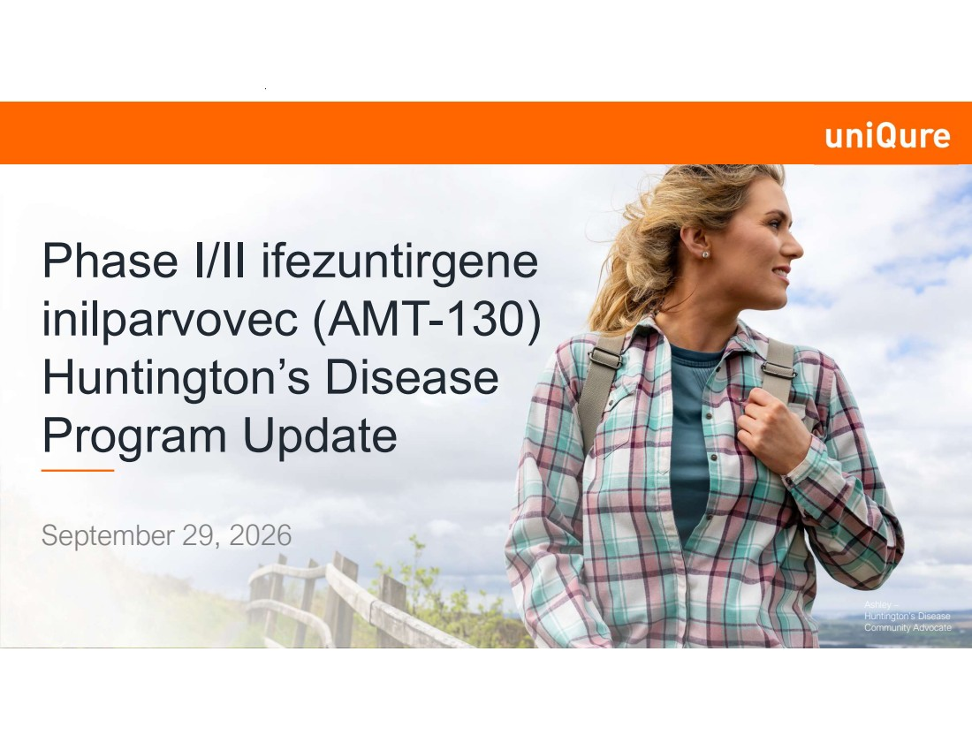 | Ashley – Huntington’s Disease Community Advocate Phase I/II ifezuntirgene inilparvovec (AMT-130) Huntington’s Disease Program Update September 29, 2026
 | 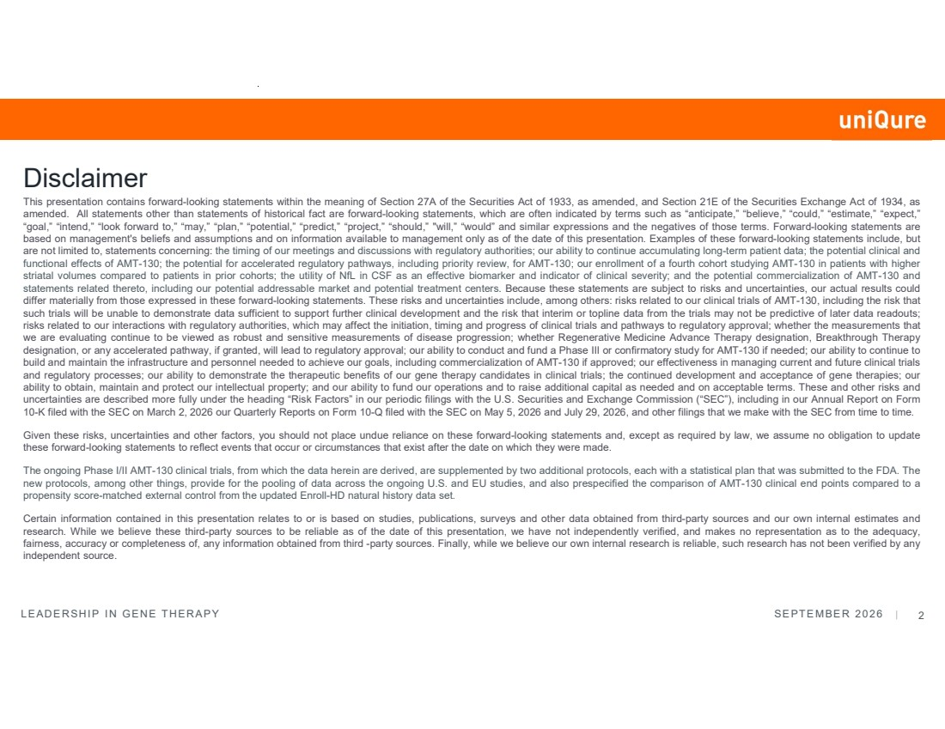 | LEADERSHIP IN GENE THERAPY SEPTEMBER 2026 | 2 This presentation contains forward-looking statements within the meaning of Section 27A of the Securities Act of 1933, as amended, and Section 21E of the Securities Exchange Act of 1934, as amended. All statements other than statements of historical fact are forward-looking statements, which are often indicated by terms such as “anticipate,” “believe,” “could,” “estimate,” “expect,” “goal,” “intend,” “look forward to,” “may,” “plan,” “potential,” “predict,” “project,” “should,” "will,” “would” and similar expressions and the negatives of those terms. Forward-looking statements are based on management's beliefs and assumptions and on information available to management only as of the date of this presentation. Examples of these forward-looking statements include, but are not limited to, statements concerning: the timing of our meetings and discussions with regulatory authorities; our ability to continue accumulating long-term patient data; the potential clinical and functional effects of AMT-130; the potential for accelerated regulatory pathways, including priority review, for AMT-130; our enrollment of a fourth cohort studying AMT-130 in patients with higher striatal volumes compared to patients in prior cohorts; the utility of NfL in CSF as an effective biomarker and indicator of clinical severity; and the potential commercialization of AMT-130 and statements related thereto, including our potential addressable market and potential treatment centers. Because these statements are subject to risks and uncertainties, our actual results could differ materially from those expressed in these forward-looking statements. These risks and uncertainties include, among others: risks related to our clinical trials of AMT-130, including the risk that such trials will be unable to demonstrate data sufficient to support further clinical development and the risk that interim or topline data from the trials may not be predictive of later data readouts; risks related to our interactions with regulatory authorities, which may affect the initiation, timing and progress of clinical trials and pathways to regulatory approval; whether the measurements that we are evaluating continue to be viewed as robust and sensitive measurements of disease progression; whether Regenerative Medicine Advance Therapy designation, Breakthrough Therapy designation, or any accelerated pathway, if granted, will lead to regulatory approval; our ability to conduct and fund a Phase III or confirmatory study for AMT-130 if needed; our ability to continue to build and maintain the infrastructure and personnel needed to achieve our goals, including commercialization of AMT-130 if approved; our effectiveness in managing current and future clinical trials and regulatory processes; our ability to demonstrate the therapeutic benefits of our gene therapy candidates in clinical trials; the continued development and acceptance of gene therapies; our ability to obtain, maintain and protect our intellectual property; and our ability to fund our operations and to raise additional capital as needed and on acceptable terms. These and other risks and uncertainties are described more fully under the heading “Risk Factors” in our periodic filings with the U.S. Securities and Exchange Commission (“SEC”), including in our Annual Report on Form 10-K filed with the SEC on March 2, 2026 our Quarterly Reports on Form 10-Q filed with the SEC on May 5, 2026 and July 29, 2026, and other filings that we make with the SEC from time to time. Given these risks, uncertainties and other factors, you should not place undue reliance on these forward-looking statements and, except as required by law, we assume no obligation to update these forward-looking statements to reflect events that occur or circumstances that exist after the date on which they were made. The ongoing Phase I/II AMT-130 clinical trials, from which the data herein are derived, are supplemented by two additional protocols, each with a statistical plan that was submitted to the FDA. The new protocols, among other things, provide for the pooling of data across the ongoing U.S. and EU studies, and also prespecified the comparison of AMT-130 clinical end points compared to a propensity score-matched external control from the updated Enroll-HD natural history data set. Certain information contained in this presentation relates to or is based on studies, publications, surveys and other data obtained from third-party sources and our own internal estimates and research. While we believe these third-party sources to be reliable as of the date of this presentation, we have not independently verified, and makes no representation as to the adequacy, fairness, accuracy or completeness of, any information obtained from third -party sources. Finally, while we believe our own internal research is reliable, such research has not been verified by any independent source. Disclaimer
 |  | Opening Remarks Matt Kapusta Chief Executive Officer
 | 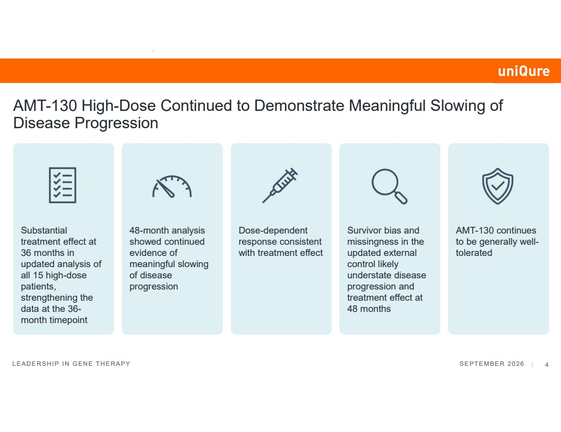 | LEADERSHIP IN GENE THERAPY SEPTEMBER 2026 | 4 AMT-130 High-Dose Continued to Demonstrate Meaningful Slowing of Disease Progression Substantial treatment effect at 36 months in updated analysis of all 15 high-dose patients, strengthening the data at the 36- month timepoint 48-month analysis showed continued evidence of meaningful slowing of disease progression Dose-dependent response consistent with treatment effect Survivor bias and missingness in the updated external control likely understate disease progression and treatment effect at 48 months AMT-130 continues to be generally well-tolerated
 | 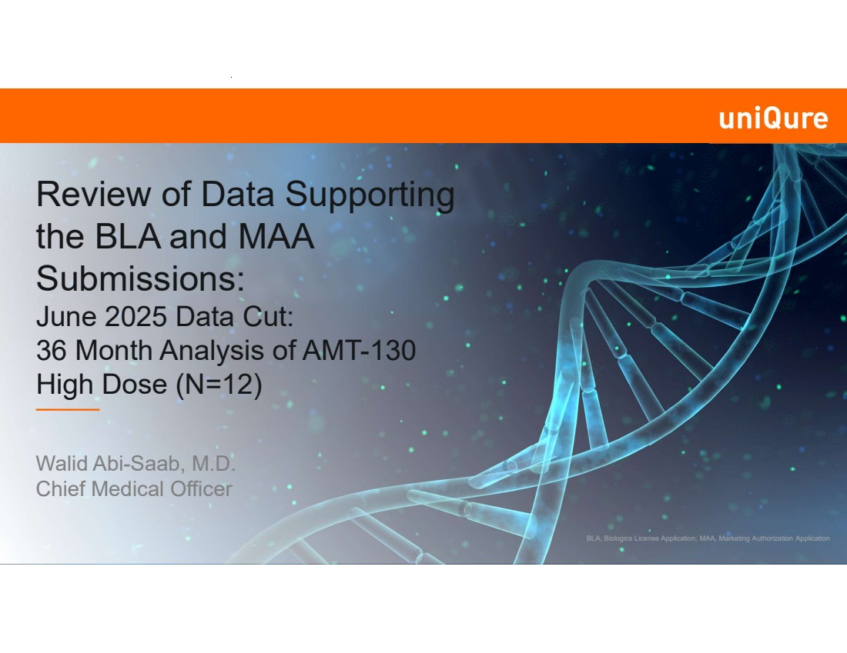 | Review of Data Supporting the BLA and MAA Submissions: June 2025 Data Cut: 36 Month Analysis of AMT-130 High Dose (N=12) Walid Abi-Saab, M.D. Chief Medical Officer BLA, Biologics License Application; MAA, Marketing Authorization Application
 | 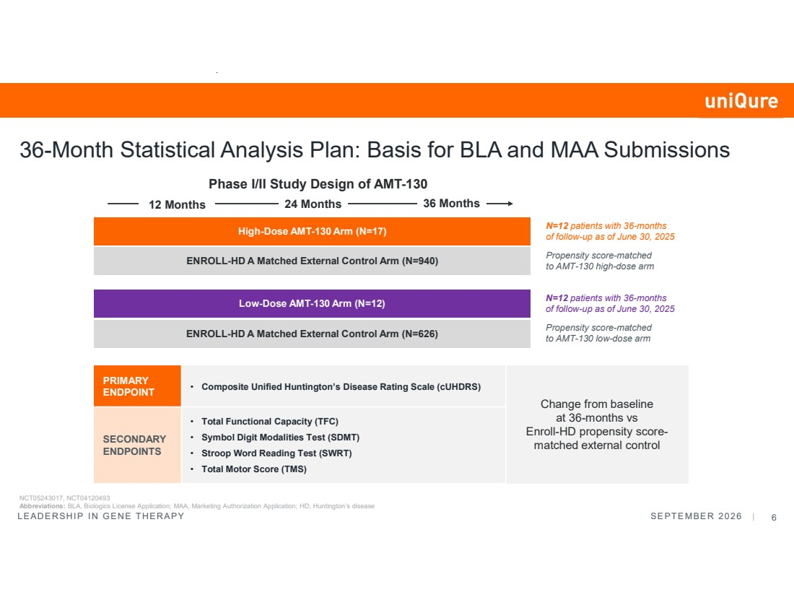 | LEADERSHIP IN GENE THERAPY SEPTEMBER 2026 | 6 36-Month Statistical Analysis Plan: Basis for BLA and MAA Submissions 12 Months 24 Months 36 Months N=12 patients with 36-months of follow-up as of June 30, 2025 Propensity score-matched to AMT-130 high-dose arm High-Dose AMT-130 Arm (N=17) ENROLL-HD A Matched External Control Arm (N=940) Low-Dose AMT-130 Arm (N=12) ENROLL-HD A Matched External Control Arm (N=626) N=12 patients with 36-months of follow-up as of June 30, 2025 Propensity score-matched to AMT-130 low-dose arm Change from baseline at 36-months vs Enroll-HD propensity score-matched external control • Composite Unified Huntington’s Disease Rating Scale (cUHDRS) PRIMARY ENDPOINT • Total Functional Capacity (TFC) • Symbol Digit Modalities Test (SDMT) • Stroop Word Reading Test (SWRT) • Total Motor Score (TMS) SECONDARY ENDPOINTS Phase I/II Study Design of AMT-130 NCT05243017, NCT04120493 Abbreviations: BLA, Biologics License Application; MAA, Marketing Authorization Application; HD, Huntington’s disease
 | 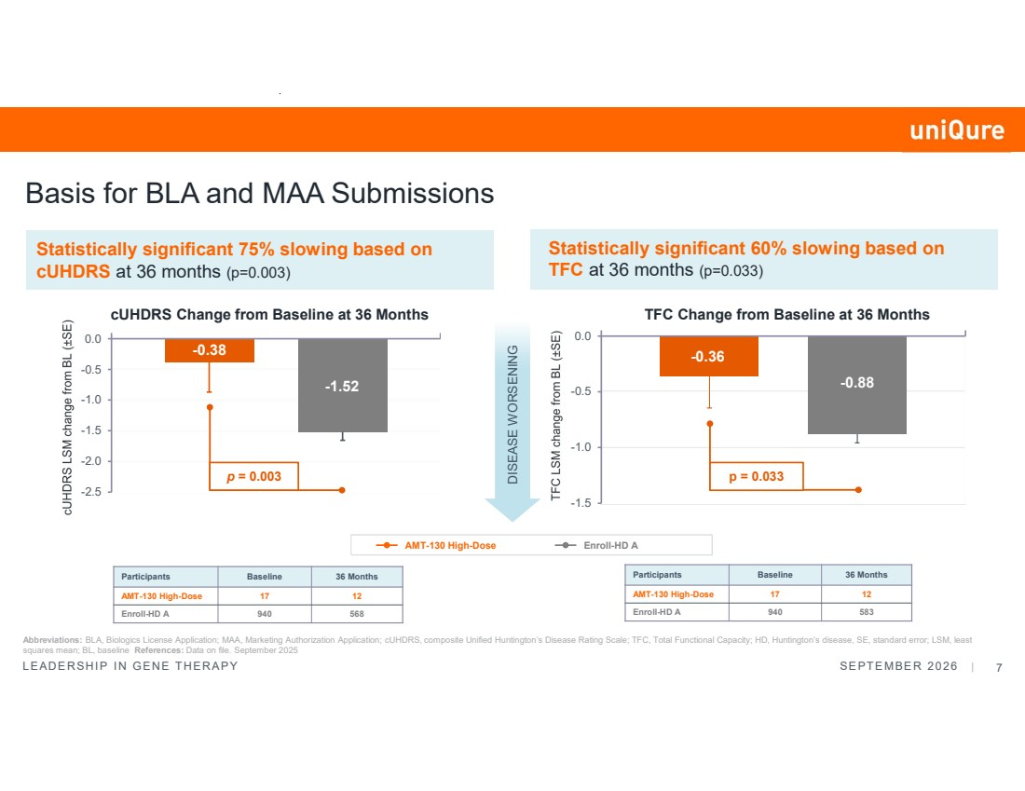 | LEADERSHIP IN GENE THERAPY SEPTEMBER 2026 | 7 Basis for BLA and MAA Submissions Statistically significant 60% slowing based on TFC at 36 months (p=0.033) Statistically significant 75% slowing based on cUHDRS at 36 months (p=0.003) Abbreviations: BLA, Biologics License Application; MAA, Marketing Authorization Application; cUHDRS, composite Unified Huntington’s Disease Rating Scale; TFC, Total Functional Capacity; HD, Huntington’s disease, SE, standard error; LSM, least squares mean; BL, baseline References: Data on file. September 2025 Participants Baseline 36 Months AMT-130 High-Dose 17 12 Enroll-HD A 940 568 Participants Baseline 36 Months AMT-130 High-Dose 17 12 Enroll-HD A 940 583 cUHDRS Change from Baseline at 36 Months DISEASE WORSENING TFC Change from Baseline at 36 Months AMT-130 High-Dose Enroll-HD A -0.38 -1.52 -2.5 -2.0 -1.5 -1.0 -0.5 0.0 p = 0.003 -0.36 -0.88 -1.5 -1.0 -0.5 0.0 p = 0.033
 |  | Data as of June 30, 2026 Primary Analysis: Results at 48 Months from the Phase I/II Study
 | 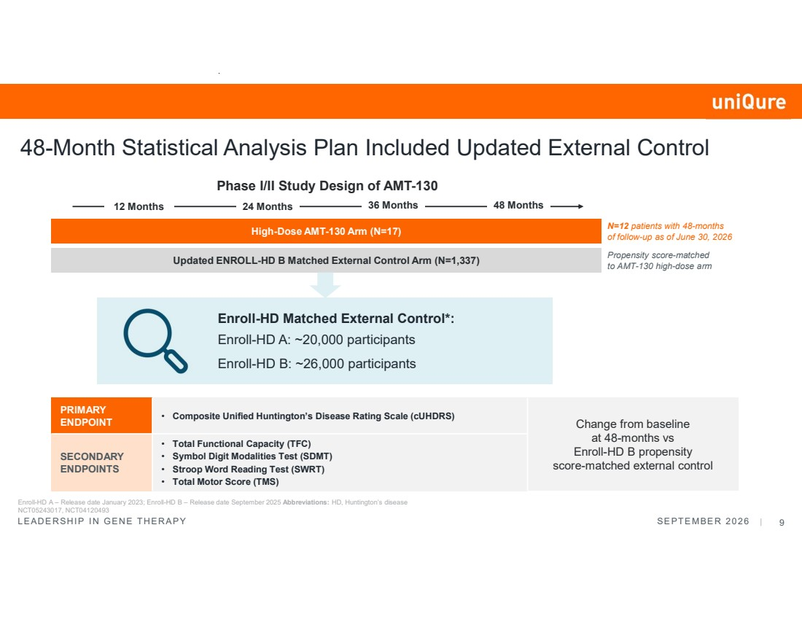 | LEADERSHIP IN GENE THERAPY SEPTEMBER 2026 | 9 Enroll-HD A – Release date January 2023; Enroll-HD B – Release date September 2025 Abbreviations: HD, Huntington’s disease NCT05243017, NCT04120493 48-Month Statistical Analysis Plan Included Updated External Control High-Dose AMT-130 Arm (N=17) Updated ENROLL-HD B Matched External Control Arm (N=1,337) 12 Months 24 Months 36 Months N=12 patients with 48-months of follow-up as of June 30, 2026 Propensity score-matched to AMT-130 high-dose arm Enroll-HD Matched External Control*: Enroll-HD A: ~20,000 participants Enroll-HD B: ~26,000 participants 48 Months Phase I/II Study Design of AMT-130 Change from baseline at 48-months vs Enroll-HD B propensity score-matched external control • Composite Unified Huntington’s Disease Rating Scale (cUHDRS) PRIMARY ENDPOINT • Total Functional Capacity (TFC) • Symbol Digit Modalities Test (SDMT) • Stroop Word Reading Test (SWRT) • Total Motor Score (TMS) SECONDARY ENDPOINTS
 | 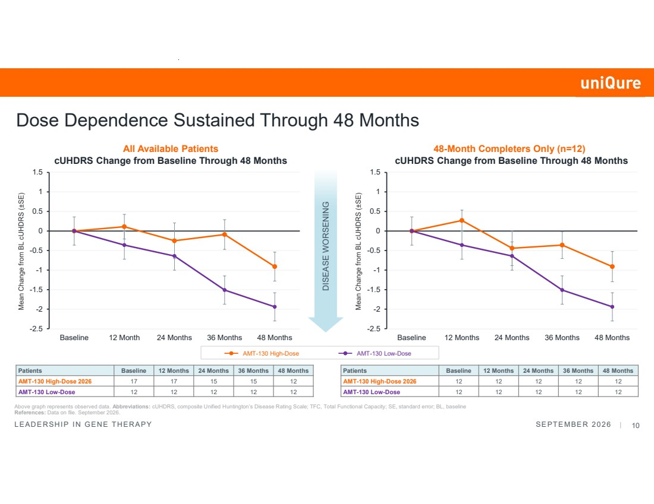 | LEADERSHIP IN GENE THERAPY SEPTEMBER 2026 | 10 Dose Dependence Sustained Through 48 Months Above graph represents observed data. Abbreviations: cUHDRS, composite Unified Huntington’s Disease Rating Scale; TFC, Total Functional Capacity; SE, standard error; BL, baseline References: Data on file. September 2026. cUHDRS Change from Baseline Through 48 Months -2.5 -2 -1.5 -1 -0.5 0 0.5 1 1.5 Baseline 12 Month 24 Months 36 Months 48 Months DISEASE WORSENING Patients Baseline 12 Months 24 Months 36 Months 48 Months AMT-130 High-Dose 2026 17 17 15 15 12 AMT-130 Low-Dose 12 12 12 12 12 AMT-130 High-Dose AMT-130 Low-Dose Patients Baseline 12 Months 24 Months 36 Months 48 Months AMT-130 High-Dose 2026 12 12 12 12 12 AMT-130 Low-Dose 12 12 12 12 12 cUHDRS Change from Baseline Through 48 Months -2.5 -2 -1.5 -1 -0.5 0 0.5 1 1.5 Baseline 12 Months 24 Months 36 Months 48 Months All Available Patients 48-Month Completers Only (n=12)
 | 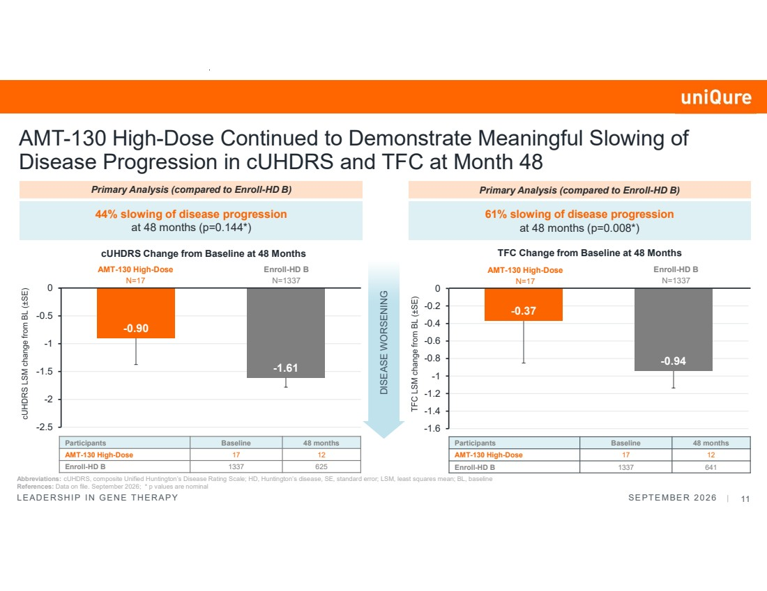 | LEADERSHIP IN GENE THERAPY SEPTEMBER 2026 | 11 AMT-130 High-Dose Continued to Demonstrate Meaningful Slowing of Disease Progression in cUHDRS and TFC at Month 48 DISEASE WORSENING Abbreviations: cUHDRS, composite Unified Huntington’s Disease Rating Scale; HD, Huntington’s disease, SE, standard error; LSM, least squares mean; BL, baseline References: Data on file. September 2026; * p values are nominal 44% slowing of disease progression at 48 months (p=0.144*) Participants Baseline 48 months AMT-130 High-Dose 17 12 Enroll-HD B 1337 625 -0.90 -1.61 -2.5 -2 -1.5 -1 -0.5 0 cUHDRS Change from Baseline at 48 Months AMT-130 High-Dose N=17 Primary Analysis (compared to Enroll-HD B) Enroll-HD B N=1337 -0.37 -0.94 -1.6 -1.4 -1.2 -1 -0.8 -0.6 -0.4 -0.2 0 61% slowing of disease progression at 48 months (p=0.008*) Participants Baseline 48 months AMT-130 High-Dose 17 12 Enroll-HD B 1337 641 TFC Change from Baseline at 48 Months Primary Analysis (compared to Enroll-HD B) AMT-130 High-Dose N=17 Enroll-HD B N=1337
 | 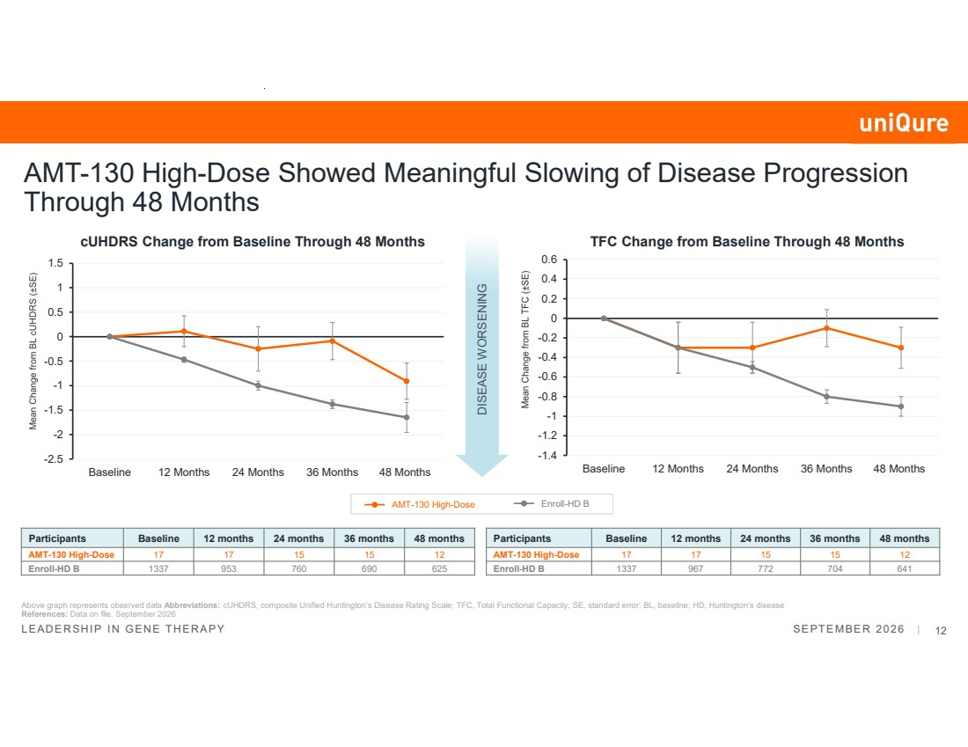 | LEADERSHIP IN GENE THERAPY SEPTEMBER 2026 | 12 Participants Baseline 12 months 24 months 36 months 48 months AMT-130 High-Dose 17 17 15 15 12 Enroll-HD B 1337 967 772 704 641 DISEASE WORSENING Participants Baseline 12 months 24 months 36 months 48 months AMT-130 High-Dose 17 17 15 15 12 Enroll-HD B 1337 953 760 690 625 AMT-130 High-Dose Showed Meaningful Slowing of Disease Progression Through 48 Months Above graph represents observed data Abbreviations: cUHDRS, composite Unified Huntington’s Disease Rating Scale; TFC, Total Functional Capacity; SE, standard error; BL, baseline; HD, Huntington’s disease References: Data on file. September 2026 cUHDRS Change from Baseline Through 48 Months TFC Change from Baseline Through 48 Months -2.5 -2 -1.5 -1 -0.5 0 0.5 1 1.5 Baseline 12 Months 24 Months 36 Months 48 Months -1.4 -1.2 -1 -0.8 -0.6 -0.4 -0.2 0 0.2 0.4 0.6 Baseline 12 Months 24 Months 36 Months 48 Months AMT-130 High-Dose Enroll-HD B
 | 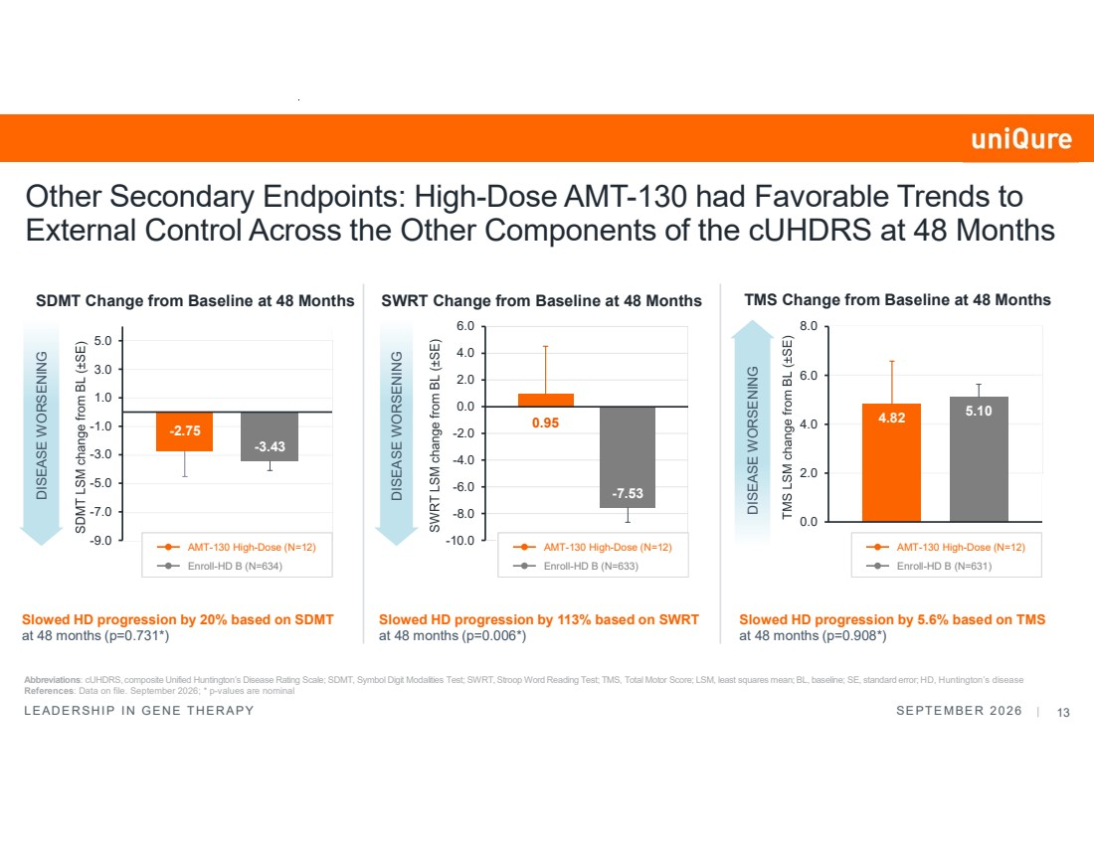 | LEADERSHIP IN GENE THERAPY SEPTEMBER 2026 | 13 Abbreviations: cUHDRS, composite Unified Huntington’s Disease Rating Scale; SDMT, Symbol Digit Modalities Test; SWRT, Stroop Word Reading Test; TMS, Total Motor Score; LSM, least squares mean; BL, baseline; SE, standard error; HD, Huntington’s disease References: Data on file. September 2026; * p-values are nominal Other Secondary Endpoints: High-Dose AMT-130 had Favorable Trends to External Control Across the Other Components of the cUHDRS at 48 Months DISEASE WORSENING DISEASE WORSENING DISEASE WORSENING Slowed HD progression by 20% based on SDMT at 48 months (p=0.731*) Slowed HD progression by 113% based on SWRT at 48 months (p=0.006*) Slowed HD progression by 5.6% based on TMS at 48 months (p=0.908*) SDMT Change from Baseline at 48 Months SWRT Change from Baseline at 48 Months TMS Change from Baseline at 48 Months -2.75 -3.43 -9.0 -7.0 -5.0 -3.0 -1.0 1.0 3.0 5.0 0.95 -7.53 -10.0 -8.0 -6.0 -4.0 -2.0 0.0 2.0 4.0 6.0 4.82 5.10 0.0 2.0 4.0 6.0 8.0 AMT-130 High-Dose (N=12) Enroll-HD B (N=634) AMT-130 High-Dose (N=12) Enroll-HD B (N=633) AMT-130 High-Dose (N=12) Enroll-HD B (N=631)
 | 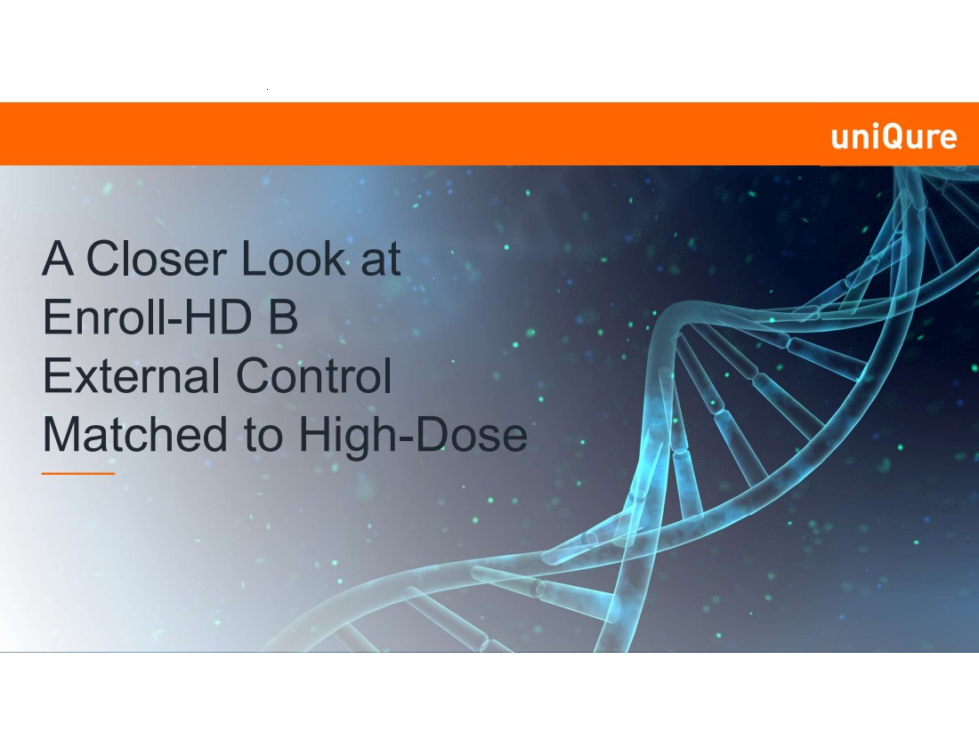 | A Closer Look at Enroll-HD B External Control Matched to High-Dose
 | 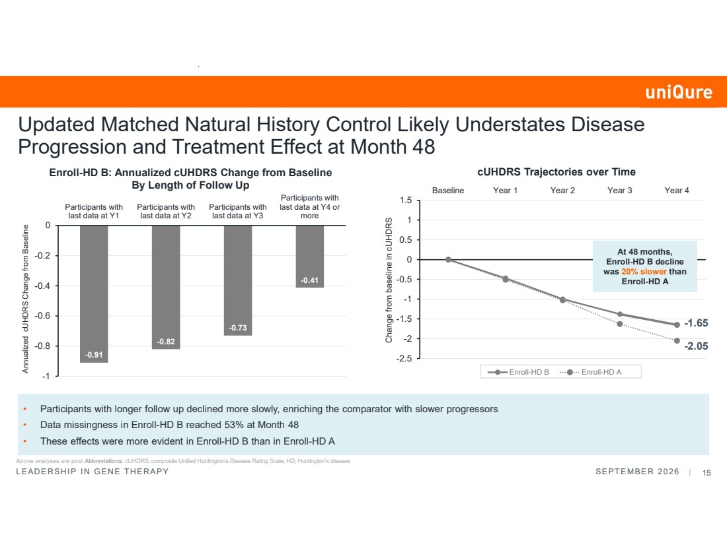 | LEADERSHIP IN GENE THERAPY SEPTEMBER 2026 | 15 Updated Matched Natural History Control Likely Understates Disease Progression and Treatment Effect at Month 48 Enroll-HD B: Annualized cUHDRS Change from Baseline By Length of Follow Up • Participants with longer follow up declined more slowly, enriching the comparator with slower progressors • Data missingness in Enroll-HD B reached 53% at Month 48 • These effects were more evident in Enroll-HD B than in Enroll-HD A -0.91 -0.82 -0.73 -0.41 -1 -0.8 -0.6 -0.4 -0.2 0 Participants with last data at Y1 Participants with last data at Y2 Participants with last data at Y3 Participants with last data at Y4 or more Annualized cUHDRS Change from Baseline cUHDRS Trajectories over Time Change from baseline in cUHDRS -2.5 -2 -1.5 -1 -0.5 0 0.5 1 1.5 Baseline Year 1 Year 2 Year 3 Year 4 Enroll-HD B Enroll-HD A At 48 months, Enroll-HD B decline was 20% slower than Enroll-HD A -1.65 -2.05 Above analyses are post Abbreviations: cUHDRS, composite Unified Huntington’s Disease Rating Scale; HD, Huntington’s disease
 |  | Post Hoc Analysis using Enroll-HD A at 48 Months from the Phase I/II Study Data as of June 30, 2026
 | 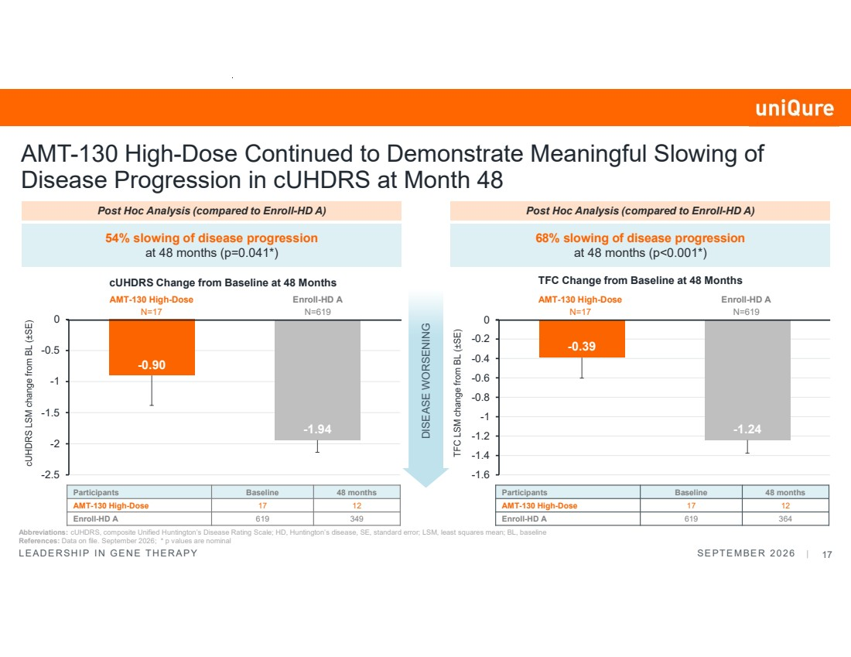 | LEADERSHIP IN GENE THERAPY SEPTEMBER 2026 | 17 -0.90 -1.94 -2.5 -2 -1.5 -1 -0.5 0 AMT-130 High-Dose Continued to Demonstrate Meaningful Slowing of Disease Progression in cUHDRS at Month 48 DISEASE WORSENING Abbreviations: cUHDRS, composite Unified Huntington’s Disease Rating Scale; HD, Huntington’s disease, SE, standard error; LSM, least squares mean; BL, baseline References: Data on file. September 2026; * p values are nominal 54% slowing of disease progression at 48 months (p=0.041*) Participants Baseline 48 months AMT-130 High-Dose 17 12 Enroll-HD A 619 349 cUHDRS Change from Baseline at 48 Months AMT-130 High-Dose N=17 Post Hoc Analysis (compared to Enroll-HD A) Enroll-HD A N=619 -0.39 -1.24 -1.6 -1.4 -1.2 -1 -0.8 -0.6 -0.4 -0.2 0 68% slowing of disease progression at 48 months (p<0.001*) Participants Baseline 48 months AMT-130 High-Dose 17 12 Enroll-HD A 619 364 TFC Change from Baseline at 48 Months Post Hoc Analysis (compared to Enroll-HD A) AMT-130 High-Dose N=17 Enroll-HD A N=619
 | 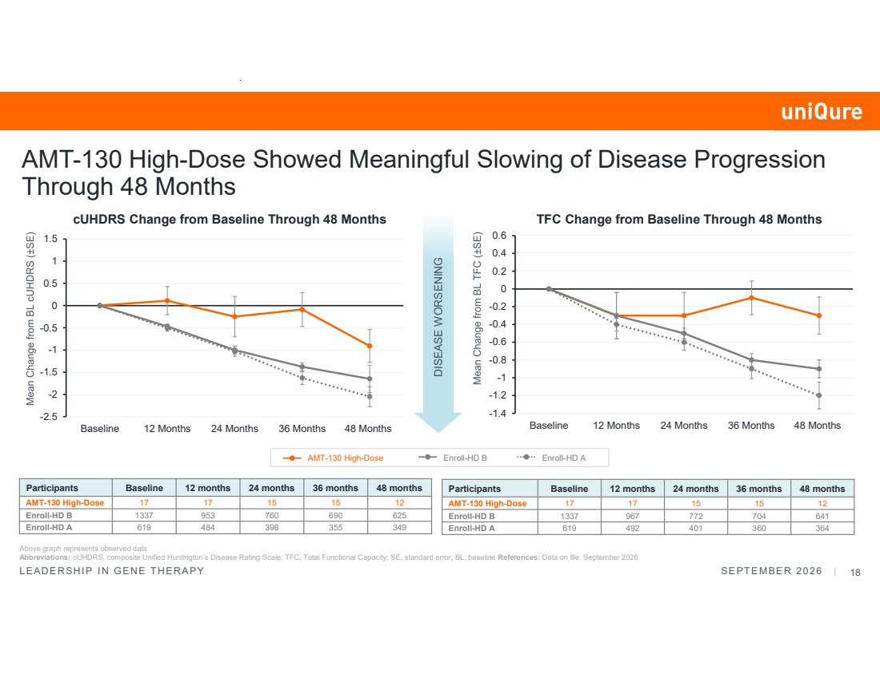 | LEADERSHIP IN GENE THERAPY SEPTEMBER 2026 | 18 DISEASE WORSENING Above graph represents observed data Abbreviations: cUHDRS, composite Unified Huntington’s Disease Rating Scale; TFC, Total Functional Capacity; SE, standard error; BL, baseline References: Data on file. September 2026 cUHDRS Change from Baseline Through 48 Months TFC Change from Baseline Through 48 Months -2.5 -2 -1.5 -1 -0.5 0 0.5 1 1.5 Baseline 12 Months 24 Months 36 Months 48 Months -1.4 -1.2 -1 -0.8 -0.6 -0.4 -0.2 0 0.2 0.4 0.6 Baseline 12 Months 24 Months 36 Months 48 Months AMT-130 High-Dose Enroll-HD B Enroll-HD A AMT-130 High-Dose Showed Meaningful Slowing of Disease Progression Through 48 Months Participants Baseline 12 months 24 months 36 months 48 months AMT-130 High-Dose 17 17 15 15 12 Enroll-HD B 1337 967 772 704 641 Enroll-HD A 619 492 401 360 364 Participants Baseline 12 months 24 months 36 months 48 months AMT-130 High-Dose 17 17 15 15 12 Enroll-HD B 1337 953 760 690 625 Enroll-HD A 619 484 398 355 349
 |  | Results at 36 Months from the Phase I/II Study Data as of June 30, 2026
 | 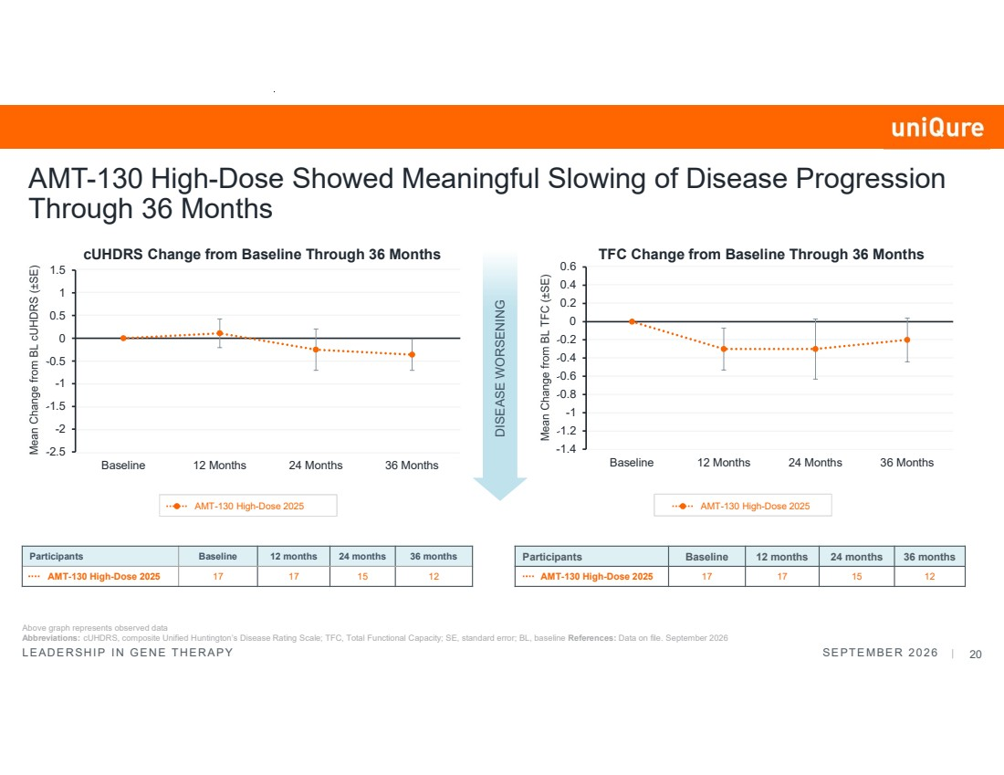 | LEADERSHIP IN GENE THERAPY SEPTEMBER 2026 | 20 -1.4 -1.2 -1 -0.8 -0.6 -0.4 -0.2 0 0.2 0.4 0.6 Baseline 12 Months 24 Months 36 Months -2.5 -2 -1.5 -1 -0.5 0 0.5 1 1.5 Baseline 12 Months 24 Months 36 Months Participants Baseline 12 months 24 months 36 months AMT-130 High-Dose 2025 17 17 15 12 AMT-130 High-Dose Showed Meaningful Slowing of Disease Progression Through 36 Months Above graph represents observed data Abbreviations: cUHDRS, composite Unified Huntington’s Disease Rating Scale; TFC, Total Functional Capacity; SE, standard error; BL, baseline References: Data on file. September 2026 DISEASE WORSENING Participants Baseline 12 months 24 months 36 months AMT-130 High-Dose 2025 17 17 15 12 cUHDRS Change from Baseline Through 36 Months TFC Change from Baseline Through 36 Months AMT-130 High-Dose 2025 AMT-130 High-Dose 2025
 | 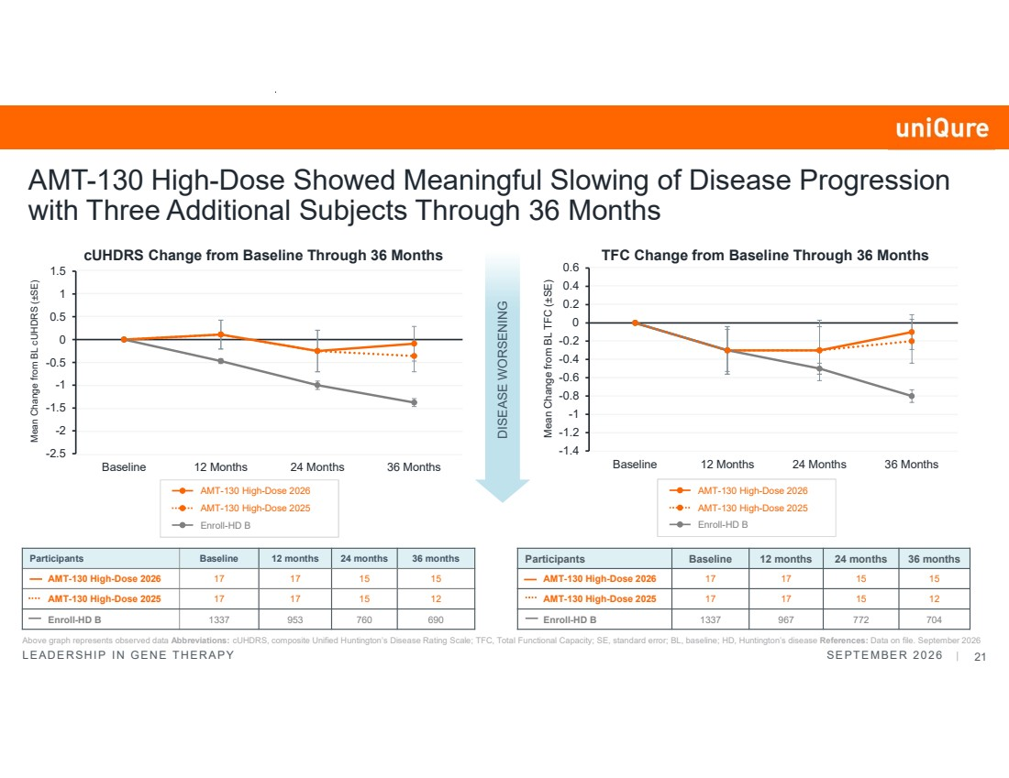 | LEADERSHIP IN GENE THERAPY SEPTEMBER 2026 | 21 -1.4 -1.2 -1 -0.8 -0.6 -0.4 -0.2 0 0.2 0.4 0.6 Baseline 12 Months 24 Months 36 Months -2.5 -2 -1.5 -1 -0.5 0 0.5 1 1.5 Baseline 12 Months 24 Months 36 Months Enroll-HD B Participants Baseline 12 months 24 months 36 months AMT-130 High-Dose 2026 17 17 15 15 AMT-130 High-Dose 2025 17 17 15 12 Enroll-HD B 1337 967 772 704 AMT-130 High-Dose Showed Meaningful Slowing of Disease Progression with Three Additional Subjects Through 36 Months Above graph represents observed data Abbreviations: cUHDRS, composite Unified Huntington’s Disease Rating Scale; TFC, Total Functional Capacity; SE, standard error; BL, baseline; HD, Huntington’s disease References: Data on file. September 2026 DISEASE WORSENING Participants Baseline 12 months 24 months 36 months AMT-130 High-Dose 2026 17 17 15 15 AMT-130 High-Dose 2025 17 17 15 12 Enroll-HD B 1337 953 760 690 Mean Change from BL cUHDRS (±SE) Mean Change from BL TFC (±SE) cUHDRS Change from Baseline Through 36 Months TFC Change from Baseline Through 36 Months AMT-130 High-Dose 2026 AMT-130 High-Dose 2025 Enroll-HD B AMT-130 High-Dose 2026 AMT-130 High-Dose 2025
 | 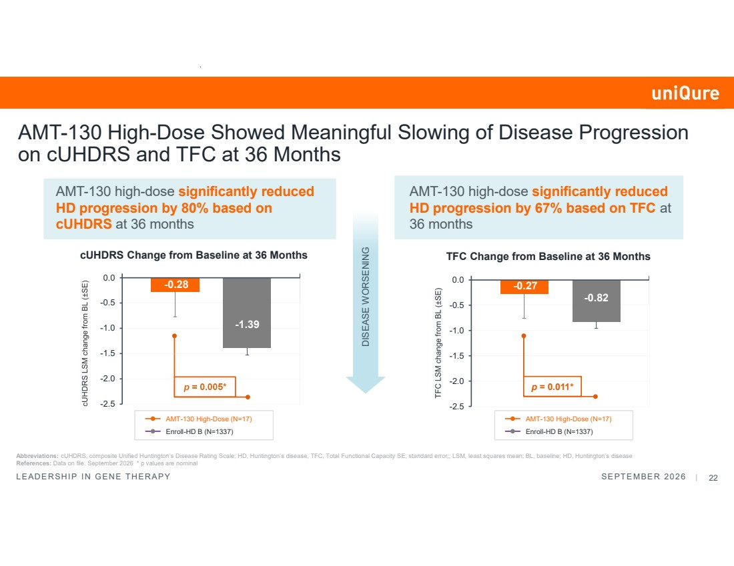 | LEADERSHIP IN GENE THERAPY SEPTEMBER 2026 | 22 Abbreviations: cUHDRS, composite Unified Huntington’s Disease Rating Scale; HD, Huntington’s disease, TFC, Total Functional Capacity SE, standard error;; LSM, least squares mean; BL, baseline; HD, Huntington’s disease References: Data on file. September 2026 * p values are nominal AMT-130 high-dose significantly reduced HD progression by 80% based on cUHDRS at 36 months cUHDRS Change from Baseline at 36 Months TFC Change from Baseline at 36 Months DISEASE WORSENING p = 0.005* AMT-130 High-Dose Showed Meaningful Slowing of Disease Progression on cUHDRS and TFC at 36 Months -0.27 -0.82 -2.5 -2.0 -1.5 -1.0 -0.5 0.0 p = 0.011* AMT-130 high-dose significantly reduced HD progression by 67% based on TFC at 36 months -0.28 -1.39 -2.5 -2.0 -1.5 -1.0 -0.5 0.0 AMT-130 High-Dose (N=17) Enroll-HD B (N=1337) AMT-130 High-Dose (N=17) Enroll-HD B (N=1337)
 | 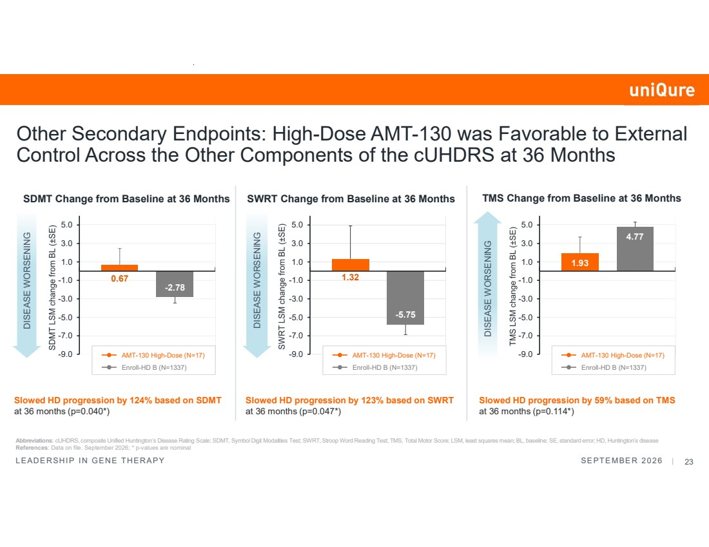 | LEADERSHIP IN GENE THERAPY SEPTEMBER 2026 | 23 Abbreviations: cUHDRS, composite Unified Huntington’s Disease Rating Scale; SDMT, Symbol Digit Modalities Test; SWRT, Stroop Word Reading Test; TMS, Total Motor Score; LSM, least squares mean; BL, baseline; SE, standard error; HD, Huntington’s disease References: Data on file. September 2026; * p-values are nominal Other Secondary Endpoints: High-Dose AMT-130 was Favorable to External Control Across the Other Components of the cUHDRS at 36 Months DISEASE WORSENING DISEASE WORSENING DISEASE WORSENING Slowed HD progression by 124% based on SDMT at 36 months (p=0.040*) Slowed HD progression by 123% based on SWRT at 36 months (p=0.047*) Slowed HD progression by 59% based on TMS at 36 months (p=0.114*) SDMT Change from Baseline at 36 Months SWRT Change from Baseline at 36 Months TMS Change from Baseline at 36 Months 0.67 -2.78 -9.0 -7.0 -5.0 -3.0 -1.0 1.0 3.0 5.0 1.32 -5.75 -9.0 -7.0 -5.0 -3.0 -1.0 1.0 3.0 5.0 1.93 4.77 -9.0 -7.0 -5.0 -3.0 -1.0 1.0 3.0 5.0 AMT-130 High-Dose (N=17) Enroll-HD B (N=1337) AMT-130 High-Dose (N=17) Enroll-HD B (N=1337) AMT-130 High-Dose (N=17) Enroll-HD B (N=1337)
 |  | Neurofilament Light Chain (NfL)
 | 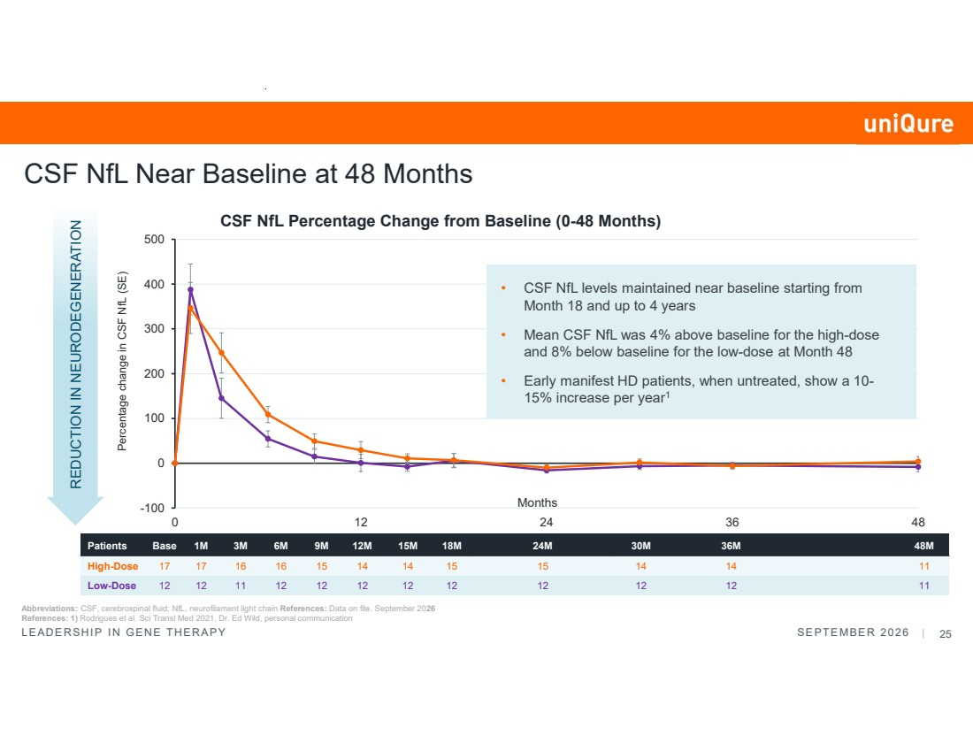 | LEADERSHIP IN GENE THERAPY SEPTEMBER 2026 | 25 -100 0 100 200 300 400 500 0 12 24 36 48 Percentage change in CSF NfL (SE) Months CSF NfL Percentage Change from Baseline (0-48 Months) Patients Base 1M 3M 6M 9M 12M 15M 18M 24M 30M 36M 48M High-Dose 17 17 16 16 15 14 14 15 15 14 14 11 Low-Dose 12 12 11 12 12 12 12 12 12 12 12 11 REDUCTION IN NEURODEGENERATION Abbreviations: CSF, cerebrospinal fluid; NfL, neurofilament light chain References: Data on file. September 2026 References: 1) Rodrigues et al. Sci Transl Med 2021, Dr. Ed Wild, personal communication CSF NfL Near Baseline at 48 Months • CSF NfL levels maintained near baseline starting from Month 18 and up to 4 years • Mean CSF NfL was 4% above baseline for the high-dose and 8% below baseline for the low-dose at Month 48 • Early manifest HD patients, when untreated, show a 10- 15% increase per year1
 |  | Safety
 | 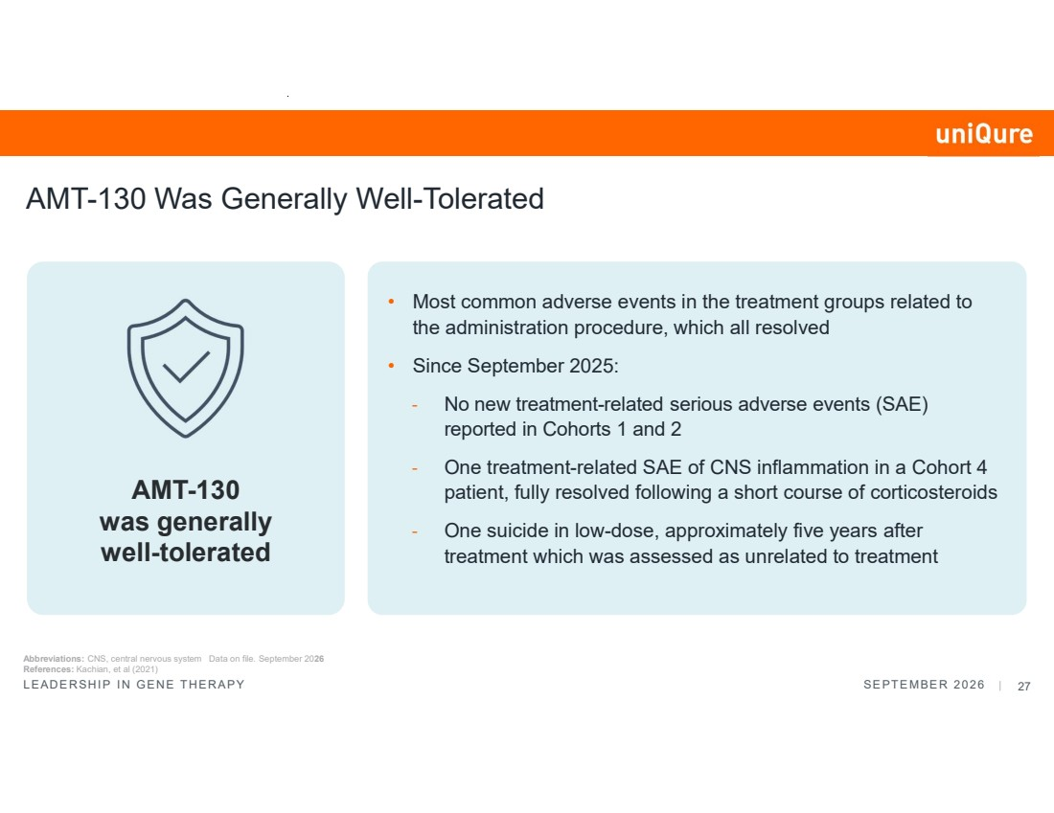 | LEADERSHIP IN GENE THERAPY SEPTEMBER 2026 | 27 AMT-130 Was Generally Well-Tolerated • Most common adverse events in the treatment groups related to the administration procedure, which all resolved • Since September 2025: - No new treatment-related serious adverse events (SAE) reported in Cohorts 1 and 2 - One treatment-related SAE of CNS inflammation in a Cohort 4 patient, fully resolved following a short course of corticosteroids - One suicide in low-dose, approximately five years after treatment which was assessed as unrelated to treatment AMT-130 was generally well-tolerated Abbreviations: CNS, central nervous system Data on file. September 2026 References: Kachian, et al (2021)
 | 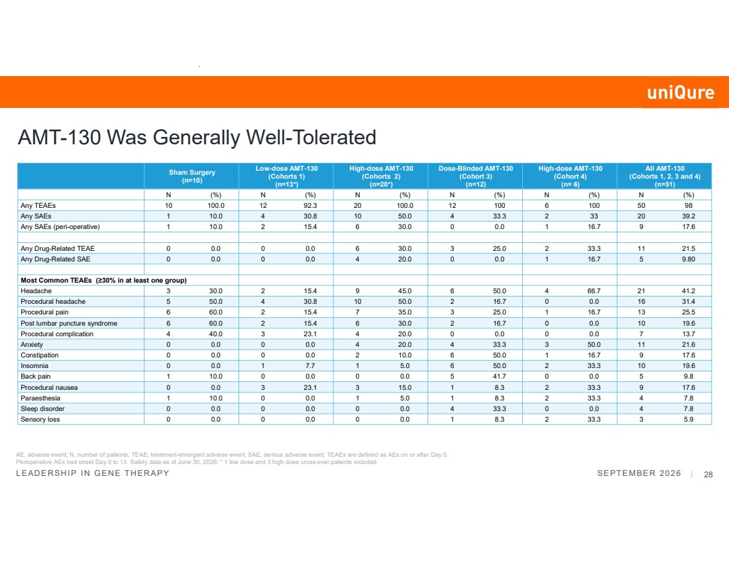 | LEADERSHIP IN GENE THERAPY SEPTEMBER 2026 | 28 All AMT-130 (Cohorts 1, 2, 3 and 4) (n=51) High-dose AMT-130 (Cohort 4) (n= 6) Dose-Blinded AMT-130 (Cohort 3) (n=12) High-dose AMT-130 (Cohorts 2) (n=20*) Low-dose AMT-130 (Cohorts 1) (n=13*) Sham Surgery (n=10) N (%) N (%) N (%) N (%) N (%) N (%) Any TEAEs 10 100.0 12 92.3 20 100.0 12 100 6 100 50 98 Any SAEs 1 10.0 4 30.8 10 50.0 4 33.3 2 33 20 39.2 Any SAEs (peri-operative) 1 10.0 2 15.4 6 30.0 0 0.0 1 16.7 9 17.6 Any Drug-Related TEAE 0 0.0 0 0.0 6 30.0 3 25.0 2 33.3 11 21.5 Any Drug-Related SAE 0 0.0 0 0.0 4 20.0 0 0.0 1 16.7 5 9.80 Most Common TEAEs (≥30% in at least one group) Headache 3 30.0 2 15.4 9 45.0 6 50.0 4 66.7 21 41.2 Procedural headache 5 50.0 4 30.8 10 50.0 2 16.7 0 0.0 16 31.4 Procedural pain 6 60.0 2 15.4 7 35.0 3 25.0 1 16.7 13 25.5 Post lumbar puncture syndrome 6 60.0 2 15.4 6 30.0 2 16.7 0 0.0 10 19.6 Procedural complication 4 40.0 3 23.1 4 20.0 0 0.0 0 0.0 7 13.7 Anxiety 0 0.0 0 0.0 4 20.0 4 33.3 3 50.0 11 21.6 Constipation 0 0.0 0 0.0 2 10.0 6 50.0 1 16.7 9 17.6 Insomnia 0 0.0 1 7.7 1 5.0 6 50.0 2 33.3 10 19.6 Back pain 1 10.0 0 0.0 0 0.0 5 41.7 0 0.0 5 9.8 Procedural nausea 0 0.0 3 23.1 3 15.0 1 8.3 2 33.3 9 17.6 Paraesthesia 1 10.0 0 0.0 1 5.0 1 8.3 2 33.3 4 7.8 Sleep disorder 0 0.0 0 0.0 0 0.0 4 33.3 0 0.0 4 7.8 Sensory loss 0 0.0 0 0.0 0 0.0 1 8.3 2 33.3 3 5.9 AE, adverse event; N, number of patients; TEAE, treatment-emergent adverse event; SAE, serious adverse event. TEAEs are defined as AEs on or after Day 0. Perioperative AEs had onset Day 0 to 13. Safety data as of June 30, 2026; * 1 low dose and 3 high dose cross-over patients included AMT-130 Was Generally Well-Tolerated
 |  | Summary
 | 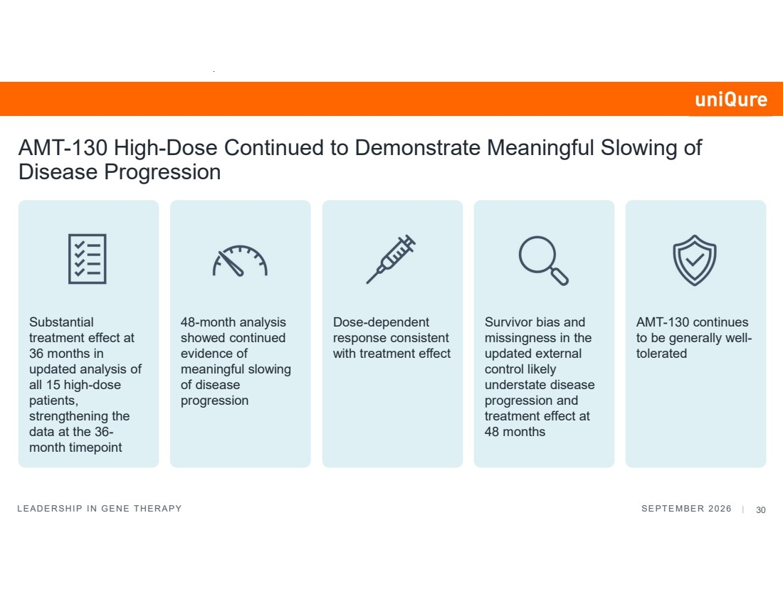 | LEADERSHIP IN GENE THERAPY SEPTEMBER 2026 | 30 AMT-130 High-Dose Continued to Demonstrate Meaningful Slowing of Disease Progression Substantial treatment effect at 36 months in updated analysis of all 15 high-dose patients, strengthening the data at the 36- month timepoint 48-month analysis showed continued evidence of meaningful slowing of disease progression Dose-dependent response consistent with treatment effect Survivor bias and missingness in the updated external control likely understate disease progression and treatment effect at 48 months AMT-130 continues to be generally well-tolerated
 |  | Clinician’s Perspective Victor Sung, M.D. University of Alabama at Birmingham (UAB)
 |  | Research Analyst Questions
 |  | Ashley – Huntington’s Disease Community Advocate Closing Remarks Matt Kapusta Chief Executive Officer

Exhibit 99.2

uniQure Announces Additional Data from Ongoing Phase I/II Studies of ifezuntirgene inilparvovec (AMT-130) in Huntington’s Disease Showing Continued Slowing of Disease Progression

~ In 12 high-dose patients at 48 months, both cUHDRS and TFC continued to demonstrate meaningful slowing of disease progression and clear dose-dependent response; the primary endpoint of cUHDRS showed 44% slowing of disease progression (non-significant p=0.144) and TFC showed a 61% slowing of disease progression (nominal p=0.008) ~

~ Updated data reflecting all 15 high-dose patients showed substantial treatment effect on both cUHDRS and TFC at 36 months, the timepoint that is the regulatory anchor for the submitted BLA and the confirmatory study; the new analysis demonstrated 80% slowing of disease progression based on cUHDRS (nominal p=0.005) and 67% based on TFC (nominal p=0.011) ~

~ Treatment effect at 48 months likely understated by substantial missing data and survivor bias in updated external control; post hoc analysis using prior external control showed slowing of disease of 54% on cUHDRS (nominal p=0.041) and 68% on TFC (nominal p=0.001) at 48 months ~

~ These positive data are meaningful for Huntington's disease patients who currently have no approved disease-modifying treatment options ~

~ Investor conference call and webcast today at 8:30 a.m. ET ~

Lexington, MA and Amsterdam, the Netherlands, September 29, 2026 — uniQure N.V. (NASDAQ: QURE), a leading gene therapy company advancing transformative therapies for patients with severe medical needs, today announced additional data from the ongoing Phase I/II studies of ifezuntirgene inilparvovec for the treatment of Huntington’s disease.

“Four years after a single administration, ifezuntirgene inilparvovec continues to show meaningful slowing of disease progression, further strengthening our conviction in its benefit for people living with Huntington’s disease," stated Walid Abi-Saab, M.D., chief medical officer of uniQure. "At 48 months, Total Functional Capacity (TFC), the primary measure of our confirmatory study, demonstrated consistent slowing of functional decline, with the absolute treatment benefit maintained in Month 48. Furthermore, the observed differences between the high and low doses on both composite Unified Huntington’s Disease Rating Scale (cUHDRS) and TFC are consistent with a dose-dependent treatment effect. The updated 36-month analysis, which now includes three additional high-dose patients, showed a substantial effect on cUHDRS and TFC, further reinforcing the data included in our license applications. We believe these data are clinically meaningful for Huntington’s disease patients, and we look forward to presenting them at a future scientific meeting.”

Topline Clinical Data at 36 months and 48 months1

Today's announcement comprises results from the ongoing Phase I/II studies at two timepoints, with a data cutoff of June 30, 2026. Twenty-nine patients have been treated with ifezuntirgene inilparvovec (n=17 high dose; n=12 low dose) across the studies’ first two cohorts. The new 36-month analysis now includes 15 high-dose and 12 low-dose patients, with three additional high-dose patients having reached that timepoint since the September 2025 analysis. The 48-month analysis includes 12 patients at each dose.

Outcomes for the 36-month and 48-month analyses were compared to propensity score-matched external controls (n=1,337 for high dose) from an updated ENROLL-HD natural history dataset with a September 2025 cutoff. As is common with longitudinal natural history studies, missingness of data increased with duration of follow-up, reaching 53% in the updated ENROLL-HD matched controls at 48 months. The Company’s analysis of the updated control showed that patients discontinuing follow-up were progressing materially faster than those remaining in the control group. The Company believes these factors likely understated disease progression in the control and the resulting treatment effect of ifezuntirgene inilparvovec at 48 months.

At the June 2026 Type B meeting, the FDA communicated that the 36-month data from 12 high-dose patients would be acceptable as the primary basis for the BLA submission under the accelerated approval pathway, and the submission was made accordingly. The BLA submission of ifezuntirgene inilparvovec predated the topline results announced today and these results were not part of the submission.

High-Dose Results at 36 Months (n=15)

 | • | cUHDRS showed 80% slowing of disease progression compared to the updated external control (nominal p=0.005). Treated patients had a mean change in cUHDRS from baseline of -0.28 compared to a change of -1.39 for the external control, a favorable treatment difference of 1.12 compared to baseline.

 | • | TFC showed 67% slowing of disease progression compared to the updated external control (nominal p=0.011). Treated patients had a mean change in TFC from baseline of -0.27 compared to a change of -0.82 for patients in the propensity score-matched external control, a favorable treatment difference of 0.55 compared to baseline.

 | • | Mean cerebrospinal neurofilament light protein (CSF NfL) was 6% below baseline (n=14).

High-Dose Results at 48 Months (n=12)

 | • | cUHDRS showed a 44% slowing of disease progression compared to the updated external control and did not reach statistical significance (p=0.144). Treated patients had a mean change in cUHDRS from baseline of -0.90 compared to a change of -1.61 for the external control, a favorable treatment difference of 0.71 compared to baseline.

 | • | TFC showed 61% slowing of disease progression compared to the updated external control (nominal p=0.008). Treated patients had a mean change in TFC from baseline of -0.37 compared to a change of -0.94 for the external control, a favorable treatment difference of 0.57 compared to baseline.

1 cUHDRS is the pre-specified primary endpoint for the 48 months analysis; all other p-values are nominal. The 36-month data included 15 high-dose patients; the 48-month analysis included 12 high-dose patients. Percentage slowing was sensitive to the magnitude of decline in the external control.

 | • | In a post-hoc sensitivity analysis using the prior ENROLL-HD external control, the 48-month analysis showed 53.5% slowing based on cUHDRS (nominal p=0.041) and 68.3% based on TFC (nominal p=0.001).

 | • | Mean cerebrospinal neurofilament light protein (CSF NfL) was 4% above baseline (n=11).

Dose Comparison at 48 Months (high dose n=12, low dose n=12)

 | • | The observed differences between the high and low doses are consistent with a dose-dependent treatment effect. At 48 months, mean change from baseline in cUHDRS was –0.91 in high-dose patients compared with −1.94 in low-dose patients, a difference of 1.03 in favor of the high dose. Mean change from baseline in TFC was −0.30 in high-dose patients compared with −0.70 in low-dose patients, a difference of 0.40 in favor of the high dose.

"Huntington’s disease does not slow on its own; the biology is one of inevitable progressive decline," stated Victor Sung, M.D., professor of neurology at the University of Alabama at Birmingham (UAB), director of the UAB Huntington’s Disease Clinic. “What I find particularly notable in the expanded data is the consistently meaningful treatment effect at 36 months, and the apparent stability of the functional capacity benefit through Month 48. We see this even as the rate of decline in the updated comparator dataset slowed, an anticipated shift which appears to reflect some attrition in the longitudinal external control data, and which does not reflect the typical clinical presentation of accelerating decline over time. Total Functional Capacity tracks things that matter the most to patients and families – ability to work, perform household chores and handle daily self-care activities. Seeing that treatment difference maintained at four years is meaningful for people living with this relentlessly progressive degenerative disease.”

Ifezuntirgene inilparvovec continues to be generally well-tolerated, with a manageable safety profile at both doses. The most common adverse events in the treatment groups were related to the administration procedure, and all have resolved. As previously disclosed, five high dose participants (17%) experienced a treatment-related serious adverse event (SAE) related to central nervous system inflammation, all of which fully resolved.

Since the September 2025 data readout, one suicide in a low-dose patient occurred, approximately five years after receiving treatment. This was assessed as unrelated to treatment by the study investigator. Suicidal ideation and completed suicide occur at substantially elevated rates in Huntington’s disease relative to the general population, and suicide is among the leading causes of death in those with the disease.

Investor Conference Call and Webcast Information

uniQure management will host an investor conference call and webcast today, Tuesday, September 29 at 8:30 a.m. ET. The event will be webcast under the Events & Presentations section of uniQure’s website at https://www.uniqure.com/investors-media/events-presentations, and following the event a replay will be archived for 90 days. Analysts wishing to participate in the question and answer session should access the live call by dialing (646) 307-1963 or toll-free (800) 715-9871 and entering conference ID 5075555. If you are joining the conference call, please join 15 minutes before the start time.

About Ifezuntirgene Inilparvovec (AMT-130)

Ifezuntirgene inilparvovec is a novel gene therapy candidate for the treatment of Huntington’s disease, which utilizes a proprietary, gene-silencing miQURE® platform and incorporates a miRNA, specifically designed to silence the huntingtin gene and the potentially highly toxic exon 1 protein fragment. Treated patients receive a single administration through targeted, MRI-guided, convection-enhanced stereotactic neurosurgical delivery directly into the striatum (caudate and putamen). Ifezuntirgene inilparvovec is the first investigational therapy for Huntington’s disease to have received Breakthrough Therapy and Regenerative Medicine Advanced Therapy (RMAT) designations from the FDA. Ifezuntirgene inilparvovec also holds Fast Track designation from the FDA.

About the Phase I/II Clinical Program of Ifezuntirgene Inilparvovec

uniQure is conducting two multi-center Phase I/II clinical studies evaluating the safety, tolerability, and efficacy of ifezuntirgene inilparvovec for the treatment of Huntington’s disease.

In total, the Phase I/II clinical studies have dosed 51 patients with ifezuntirgene inilparvovec. The U.S. randomized study enrolled 26 patients who received either a single administration of ifezuntirgene inilparvovec (n=6 low dose; n=10 high dose) or a sham procedure (n=10); four control patients subsequently crossed over to treatment after approximately 12 months. The European open-label study enrolled 13 patients (n=6 low dose; n=7 high dose). A third cohort of 12 patients explored both doses in combination with immunosuppression, and a fourth cohort of six U.S. patients is evaluating the high dose in patients with lower striatal volumes compared to those enrolled in previous cohorts.

Additional details are available on www.clinicaltrials.gov (NCT05243017, NCT04120493)

About Huntington’s Disease

Huntington’s disease is a rare, inherited neurodegenerative disorder that leads to motor symptoms including chorea, behavioral abnormalities and cognitive decline resulting in progressive physical and mental deterioration. The disease is an autosomal dominant condition with a disease-causing CAG repeat expansion in the first exon of the huntingtin gene that leads to the production and aggregation of abnormal protein in the brain. Approximately 75,000 people have Huntington’s disease in the U.S.2, EU3, and the UK4, with hundreds of thousands of others at risk of inheriting the disease. Despite the clear etiology of Huntington’s disease, there are currently no approved therapies to delay the onset or to slow the disease’s progression.

About uniQure

uniQure is delivering on the promise of gene therapy – single treatments with potentially curative results. The approvals of uniQure’s gene therapy for hemophilia B – an historic achievement based on more than a decade of research and clinical development – represent a major milestone in the field of genomic medicine and ushers in a new treatment approach for patients living with hemophilia. uniQure is now advancing a pipeline of proprietary gene therapies for the treatment of patients with Huntington's disease, refractory temporal lobe epilepsy, Fabry disease, and other severe diseases. www.uniQure.com

2 Yohrling G, et al. Neurology 2020;94(15 Suppl):954.
3 Medina A, et al. Mov Disord 2022;37(12):2327–2335
4 Furby H, et al. Eur J Neurol 2022;29(8):2249–2257.

uniQure Forward-Looking Statements

This press release contains forward-looking statements within the meaning of Section 27A of the Securities Act and Section 21E of the Exchange Act. All statements other than statements of historical fact are forward-looking statements, which are often indicated by terms such as "anticipate," "believe," "could," “establish,” "estimate," "expect," "goal," "intend," "look forward to," "may," "plan," "potential," "predict," "project," “seek,” "should," "will," "would" and similar expressions and the negatives of those terms. Forward-looking statements are based on management's beliefs and assumptions and on information available to management only as of the date of this report. Examples of these forward-looking statements include, but are not limited to, statements concerning: the Company’s beliefs related to the factors that likely understate disease progression in the updated ENROLL-HD controls and the Company’s belief that ifezuntirgene inilparvovec meaningfully reduces disease progression based on its evaluation and view of certain measurements of disease progression. The Company’s actual results could differ materially from those anticipated in these forward-looking statements for many reasons. These risks and uncertainties include, among others: risks related to the Company’s Phase I/II clinical trials of ifezuntirgene inilparvovec, including the risk that such trials will be unable to continue to demonstrate data sufficient to support further clinical development or regulatory approval; the risk that the FDA ultimately concludes that the Phase I/II trial data are not sufficient to support a BLA or accelerated approval; the risk that more patient data become available that results in a different interpretation than the one derived from the year three and four data analyses, respectively; risks related to the Company’s interactions with regulatory authorities, which may affect the initiation, timing and progress of clinical trials and pathways to regulatory approval; whether the measurements that the Company is evaluating are viewed as robust and sensitive measurements of disease progression; whether RMAT designation, Breakthrough Therapy designation, or any accelerated pathway, if granted, will lead to regulatory approval; the Company’s ability to conduct and fund any required confirmatory study for ifezuntirgene inilparvovec; the Company’s ability to successfully complete any required confirmatory study for ifezuntirgene inilparvovec; the risk that accelerated approval, if granted, may be subject to post-approval requirements that are difficult or costly to satisfy; the Company’s ability to continue to build and maintain the infrastructure and personnel needed to commercialize ifezuntirgene inilparvovec, if approved; the Company’s effectiveness in managing current and future clinical trials and regulatory processes; the Company’s ability to demonstrate the therapeutic benefits of its gene therapy candidates in clinical trials; the continued development and acceptance of gene therapies; the Company’s ability to obtain, maintain and protect its intellectual property; and the Company’s ability to fund its operations and to raise additional capital as needed and on acceptable terms. These risks and uncertainties are more fully described under the heading "Risk Factors" in the Company’s periodic filings with the U.S. Securities & Exchange Commission (“SEC”), including its Annual Report on Form 10-K filed with the SEC on March 2, 2026, its Quarterly Report on Forms 10-Q filed with the SEC on May 5, 2026 and July 29, 2026, respectively, and in other filings that the Company makes with the SEC from time to time. Given these risks, uncertainties and other factors, you should not place undue reliance on these forward-looking statements and, except as required by law, the Company assumes no obligation to update these forward-looking statements, even if new information becomes available in the future.

uniQure Contacts:
FOR INVESTORS: | FOR MEDIA:
Chiara Russo | Tom Malone
Direct: 781-491-4371 | Direct: 339-970-7558
Mobile: 617-306-9137 | Mobile:339-223-8541
c.russo@uniQure.com | t.malone@uniQure.com

